**Name: Areeba Usman**

**Sapid: 49039**

**Lab # 5:**

**Lab task 1:**

1. Run all switches with **uname** command.

-r, -m, -p, -I, -o, -a, -v, -n

And define in one line about these commands according to your understanding.

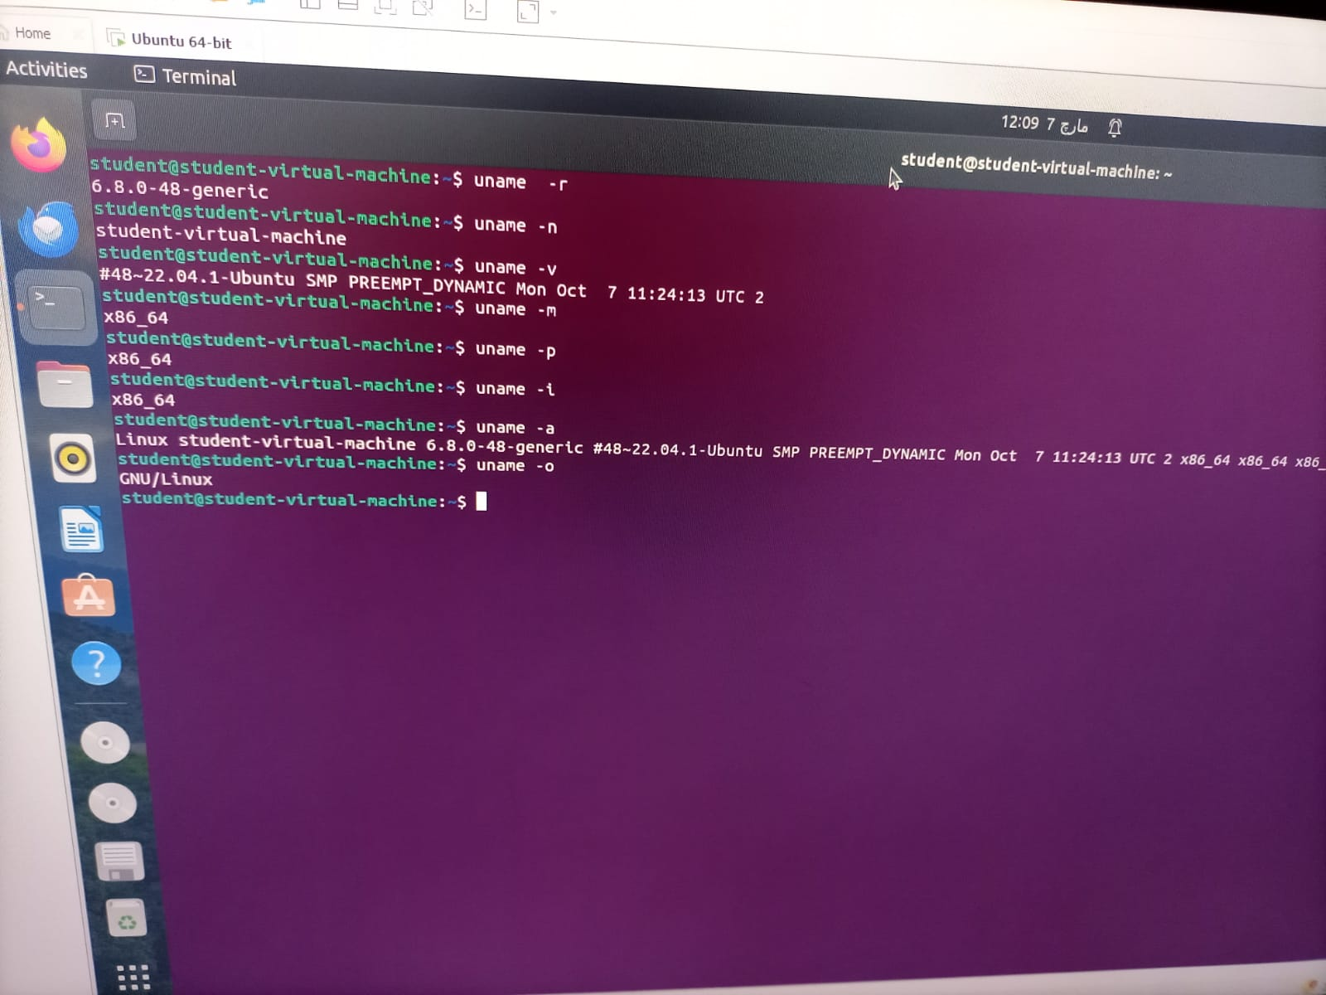

**Lab task 2:**

1. Create new file named **labSort** and insert following text

End of file

6 apples

file to be sorted

apple on the table

23 years old

File To be Sorted

78 apples

Class

3 bananas

99 sort files

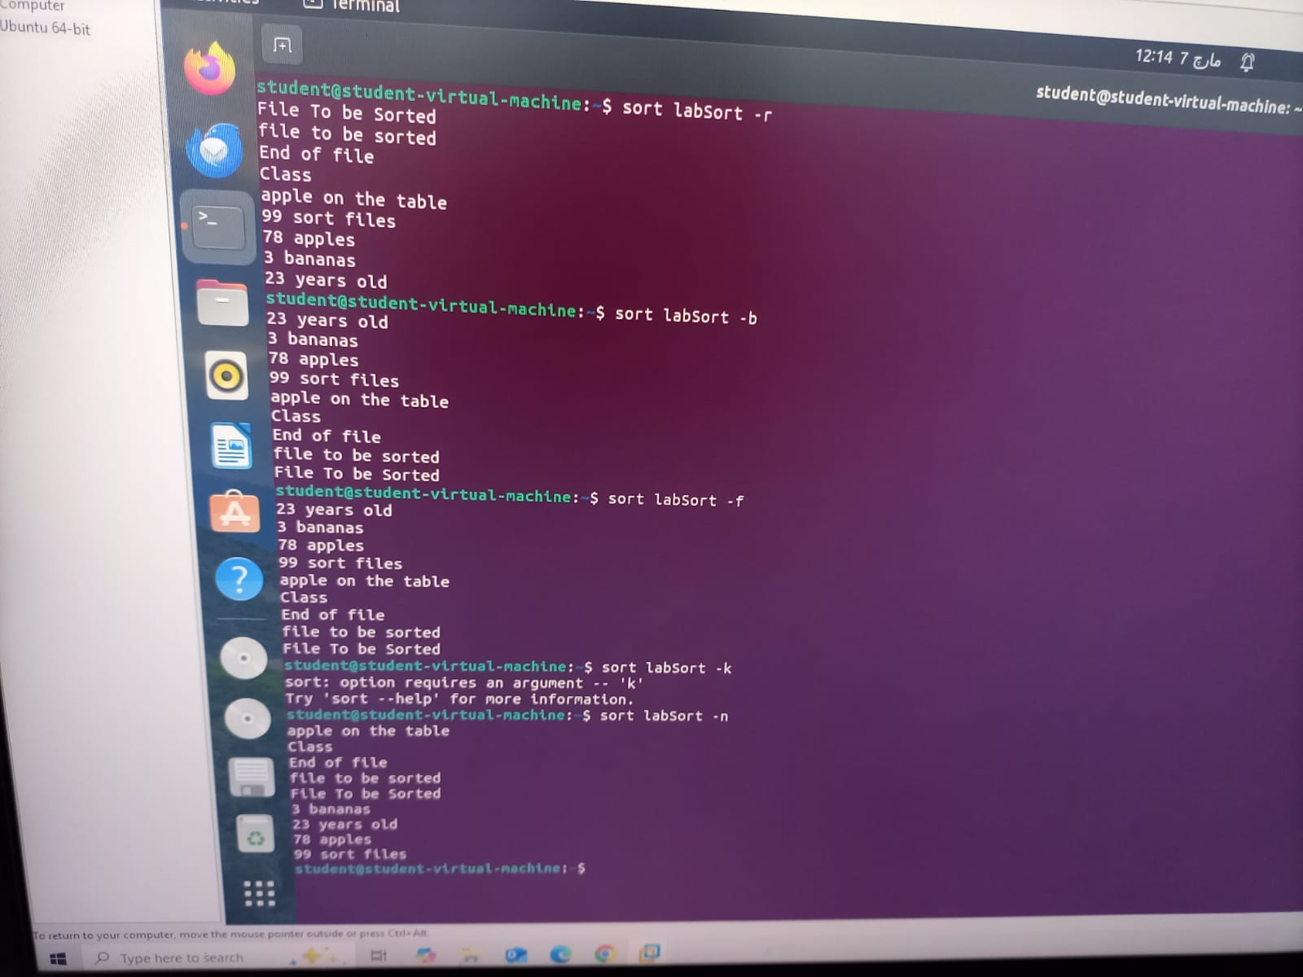

**Lab task 3:**

1. Create another file with name **SortLabNumeric** two columns in it.

12 Online classes

6 Network security

14 Hacking stories

7 Tom and jerry

13 People of Pakistan

One column contains numeric values while other contain text. Now perform sorting on both columns. Also perform **-n** switch on both columns again and observe the pattern.

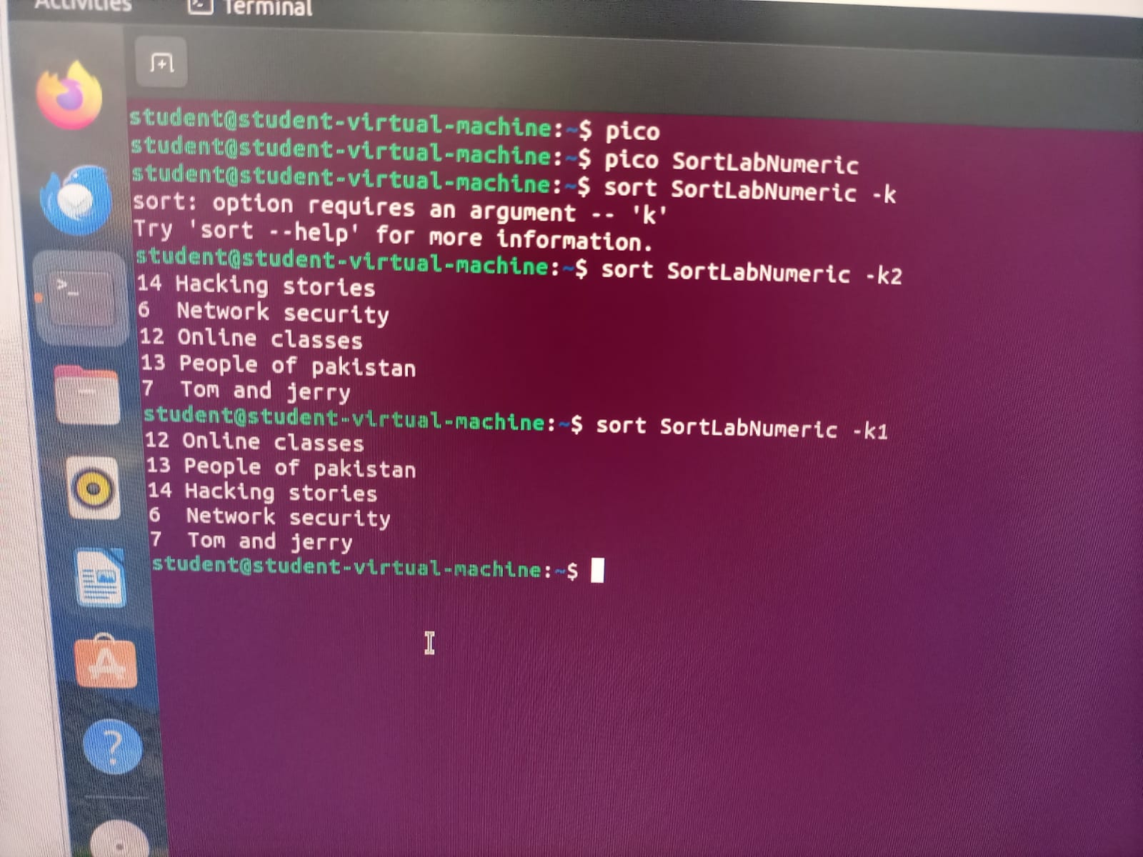

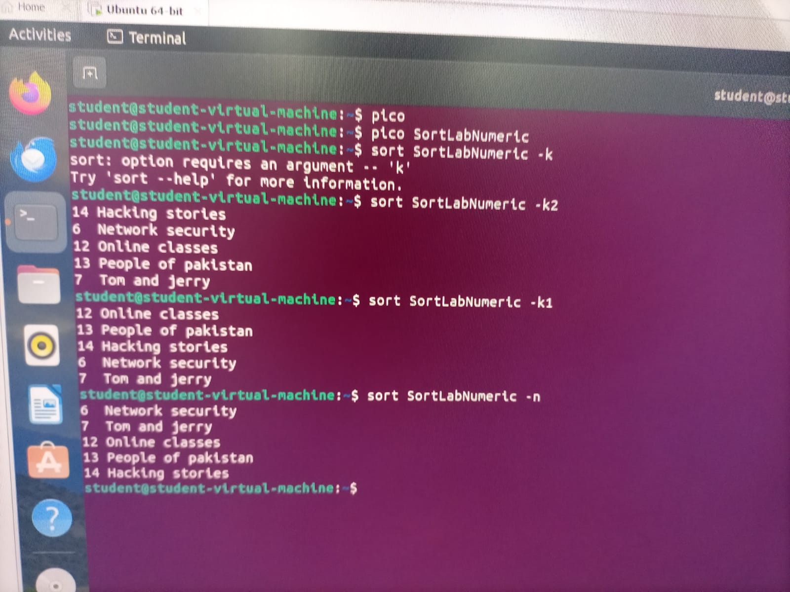

**Lab task 4:**

1. **Explain the Linux ‘cd’ command options along with the description?**

**Answer:**

The cd (change directory) command in Linux is used to navigate between directories in the terminal. Below are some commonly used options and descriptions:

| **Option** | **Description** |
| --- | --- |
| cd [directory] | Changes to the specified directory. Example: cd /home/user/Documents |
| cd (without arguments) | Moves to the home directory of the current user. Equivalent to cd ~ |
| cd ~ | Moves to the home directory of the current user. |
| cd .. | Moves up one level to the parent directory. |
|  |  |
| cd - | Switches back to the previous working directory. |
| cd / | Changes to the root directory. |